# of samples tested | # of samples with detectable fungicides | % of samples with detectable fungicides
632 | 142 | 22.47%
# of non-mig samples tested | # of non-mig samples with detectable fungicides | % of non-mig samples with detectable fungicides
350 | 89 | 20.28%
Fungicide Analysis

(Method: summary stats)
2010-2013 | n | Mean | St. Dev | Min | Max | Percent infected at detectable level | Percent infected at threshold level | t-stat | p-value
Mites per 100 bees (Fungicides) | 126 | 4.62 | 6.05 | 0 | 26.08 | 88.89% | 43.66% | -1.21 | 0.22
Mites per 100 bees (No fungicides) | 450 | 5.33 | 5.75 | 0 | 37.16 | 92.22% | 55.33% | -1.21 | 0.22
Nosema per bee (Fungicides) | 124 | 0.44 | 0.98 | 0 | 7.95 | 51.61% | 16.94% | 1.35 | 0.18
Nosema per bee (No fungicides) | 450 | 0.32 | 0.85 | 0 | 10.8 | 47.56% | 9.78% | 1.35 | 0.18

Morbidity Summary Statistics (migratory + non-migratory)

(Method: Basic t-stats)

Morbidity Summary Statistics (non-migratory only)

2010-2013 | n | Mean | St. Dev | Min | Max | Percent infected at detectable level | Percent infected at threshold level | t-stat | p-value
Mites per 100 bees (Fungicides) | 77 | 4.57 | 5.73 | 0 | 24.65 | 92.21% | 45.45% | -1.64* | 0.10
Mites per 100 bees (No fungicides) | 320 | 5.80 | 5.95 | 0 | 37.16 | 94.38% | 60.63% | -1.64* | 0.10
Nosema per bee (Fungicides) | 76 | 0.34 | 0.69 | 0 | 3 | 44.74% | 15.79% | 1.10 | 0.27
Nosema per bee (No fungicides) | 321 | 0.25 | 0.64 | 0 | 5.75 | 42.99% | 7.79% | 1.10 | 0.27

(Method: Basic t-stats)

Top Land Covers

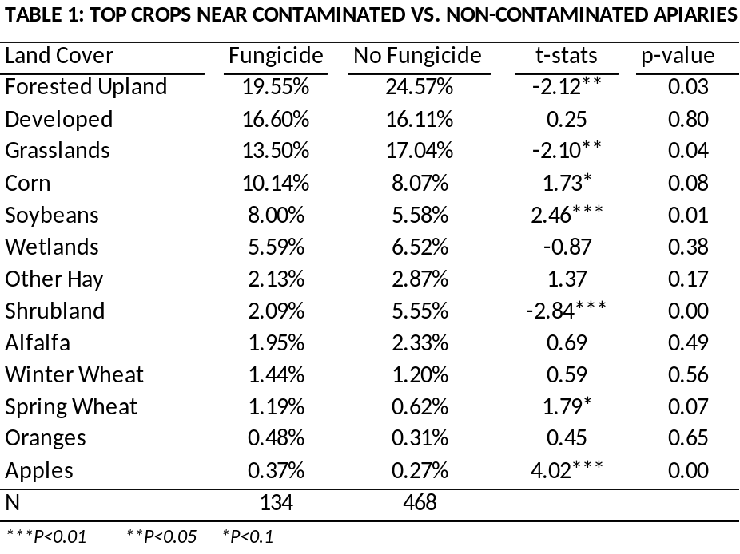

(Method: summary stats.
% of mean=mean/32,500,000, % of max=max/32,500,000)

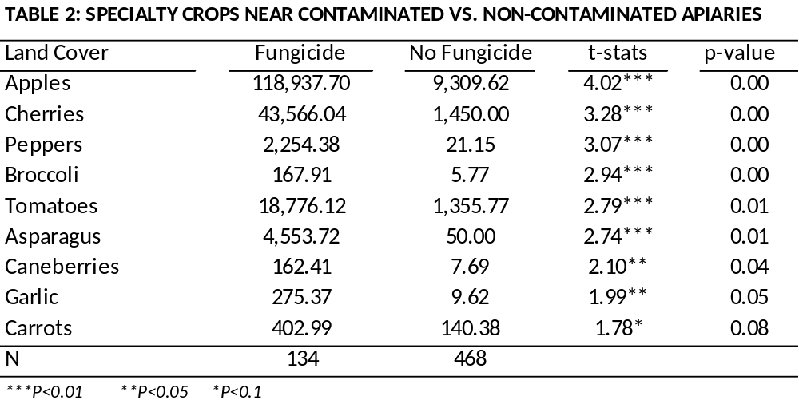
(I didn’t convert the area of crops to percentages because the numbers are comparatively small. Unit is square meters)

Detection Time and Location

Month | Count
Jan | 0
Feb | 1
Mar | 12
Apr | 11
May | 13
Jun | 13
Jul | 21
Aug | 32
Sep | 19
Oct | 11
Nov | 4
n=137
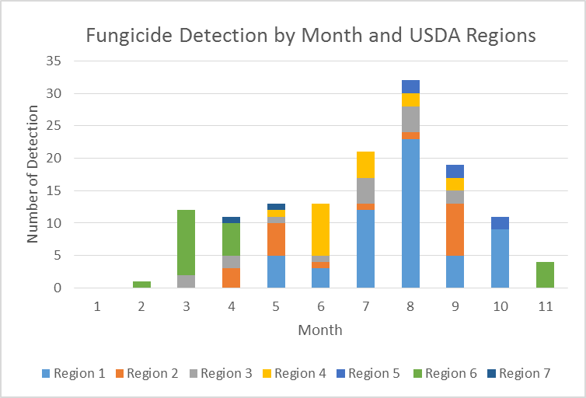

Fungicide pesticides have been mainly detected from March to November and peak from June to September. During the early months of the year, fungicides were mainly found in California. The, these pesticides have been detected in colder states from July to October and the detection moves back to warm states (FL, CA, GA) in November. Overall, USDA region 1 has been detected with the largest number (41.61%) of fungicide pesticides.

